Remembering Carol
A celebration to commemorate her life
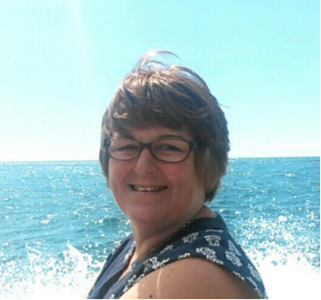
Please Join us on
Friday May 25th at 1:15pm
at South Chapel
City of London Crematorium
and then afterwards at
Wanstead Sports Club
I don’t have everyone’s contact details so please share with anyone you think might want to be there
No need to wear black
I’d like to create a memories board in advance so, soon if possible, please can you share any photos of Carol on PhotoBox ( http://www.photobox.co.uk , logon Email: ianbowe@btinternet.com Password: Bowe33 Album: Carol, or email them to me (ianbowe@btinternet.com) or share on Facebook. Also, we would greatly appreciate it if you shared any stories or memories of Carol. Thanks Ian
Family flowers only. Donations, if desired, to Cancer Research (https://www.justgiving.com/fundraising/carolbowe)
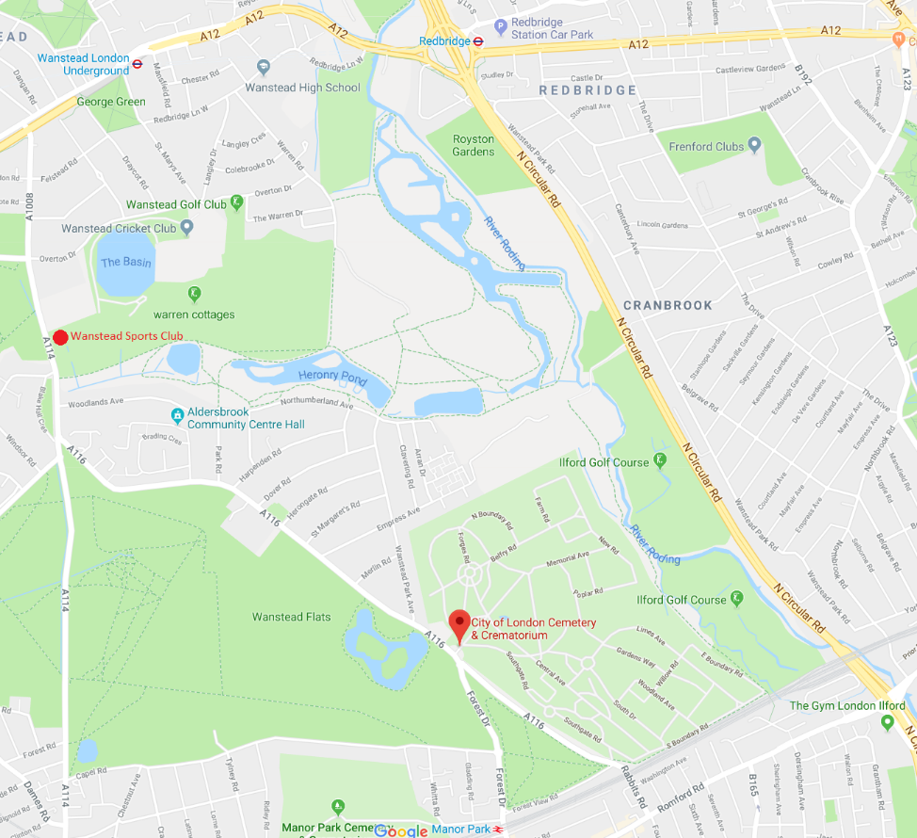
City of London Crematorium
Aldersbrook Rd,
Manor Park,
London E12 5DQ

Wanstead Sports Club
Blake Hall Club
Blake Hall Road
East London
E11 2QW
Any queries call/text me on 07919 057 841

